

**Individual Fitness Solutions Ltd**

**Membership Packet**

**General Club Information**

**Address**: 9246 Dublin Road Powell, OH 43065

**Phone #**: 614-793-1185

**Website:** ifs24hourgym.com

**Owners/Managers**: Bill & Talitha Helmling

**Phone**: 614.793.1185 (voicemail box # 1)

**Email**: ifsgym24@gmail.com

**Hours**

24 Hours/7 Days Access via Key Fob

**Staffed Hours** (*)

Monday-Friday: 6:30-7:00 Saturday: 8:00-12:00 Sunday: No Staff On Duty (Fob Access Only)

*These are guidelines only. If you are working out on your own (without a fitness trainer), please remember your key fob to guarantee access.*

**Monthly Membership Fee-Enrollment Fee**

**Single Member Rate:** $45(tax included)/month - $75 Enrollment Fee

**Couples Rate:** $69 (tax included)/month - $75 Enrollment Fee

**Family Rate:** $89 (tax included)/month - $75 Enrollment Fee

**Individual Weekly Rates**: 1 week-**$30** 2weeks-**$35** 3weeks-**$40**

**Couple Weekly Rates**: 1 week-**$55** 2weeks-**$60** 3weeks-**$65**

**Guest Fees**

Guest Pass (21 and over) with a Member $10 (Tax Included)

**Individual Fitness Solutions Ltd**

**Club Policies & Guidelines**

MEMBERS & GUESTS acknowledge that you are physically able to engage in any activity, program, or training provided and agree that all exercises and use of this facility are undertaken at your sole risk.

You also agree to accept full responsibility for all personal belongings.

**PROPER CLOTHING & HYGIENE:** Appropriate athletic shoes only are to be worn in the workout areas- no street shoes, boots, or sandals. Clean athletic shoes and workout clothing only is to be worn during workouts. Please avoid the use of heavy perfume, cologne, or lotion in the gym. No belt buckles, blue jeans, or loose jewelry can be worn in workout areas.

**EQUIPMENT USE:** Equipment must only be used for its intended purpose. Equipment may not be altered in any way. If you are not familiar with how to operate a particular piece of equipment, please arrange instruction with a staff member before using the equipment for the first time. Equipment orientation with a personal trainer is available by appointment as a service to our members.

**GYM ETIQUETTE**: No profanity, insults, or fighting allowed at any time in the club. Equipment must be picked up, replaced, and wiped down after each use. This includes the following areas:

* **Balls, Mats, BOSU, Attachments, etc.**: Return stability balls, mats, etc. to their designed storage areas. Do not leave for staff or others to pick up. All bags, coats, and belongings must be stored in cubbies or on coat hooks provided. Please use a center pull towel to wipe any sweat off of equipment.
* **Cardiovascular Equipment**: Please use center pull towels to wipe off controls, seats and hand rails whey you are finished with your workout. Clear machines of magazines, newspapers and pick up after yourself when you are done.
* **Resistance Equipment**: Please use all resistance equipment in a safe and controlled manner. Keep hands and feet away from all moving parts and weight stacks. Please wipe off the pads when you are finished with a piece of equipment. We recommend always using a spotter when training with free weights. Collars and clips are to be used for “free bar” lifting. Please return all dumbbells and plates to their appropriate racks when finished.

Please report any damaged or broken equipment to a staff member immediately. DO NOT attempt to repair or adjust any equipment that has malfunctioned. Please report any injuries to the staff. Please be courteous at all times. The management reserves the right to terminate the membership of anyone who refuses to observe the rules or regulations of the club, abuses equipment, or shows disrespect to other members and staff.

**CHARGE FOR REPLACING MEMBERSHIP CARDS:**The Club shall charge a fee for any lost or replacement membership key fob. The charge for a new key fob, whether lost or damaged will be $25.00.  
  
**DAMAGES:**Members may be held responsible for any damage to club's property. Damages to the club's property shall be paid for by any member, member's guest, or dependent children who willfully or neglectfully caused the damage.

**FIREARMS:**Firearms or weapons are prohibited in the club at any time.

**CLUB DECREE**: All members and guests are required to have fun! Please introduce yourself to your fellow members and the staff will strive to do the same. We are here to help you reach your health and fitness goals and provide you with a safe workout environment. Please let us know if you have any questions or recommendations on how we can best serve your needs.

**Individual Fitness Solutions**

**General Membership Agreement**

***(Office use only)*** *Start Date:_________ Exp.Date:___________*

**Section 1. Member Information**

Name ___________________________________ Address_________________________________________________ City/State/Zip_______________________/_________ / ___________________ Birth Month _____________________

Home Phone________________________________ Work/Cell ____________________________________________

**Section 2. Individual Fitness Solutions Ltd Terms or Agreement**

This membership is entered into between Individual Fitness Solutions Ltd (“GYM”) and __________________________, __________________________ , ___________________________, ___________________________(“MEMBER(S)”).

This membership agreement is on a month to month basis at the initial dues rate of ___$45 (Individual), ___ $69(Couple/2 people), or ____ $89 (Family/3-4 people) (Tax Included) per month payable in advance, beginning on the first day of enrollment. In conjunction with this membership agreement, MEMBER(S) has executed an Informed Consent Agreement, and a Credit Card Authorization Form with GYM. A one time enrollment/key fob fee of $75 is due on the first day of enrollment. The term of this agreement shall be month to month starting on this day: ___ / ___ /_________ (“first day of enrollment”), during which time MEMBER(S) shall be responsible for membership dues and meeting all other conditions of membership. Upon signing this Agreement, MEMBER(S) will be subject to a minimum of one month dues and any enrollment/processing fees. MEMBER(S) shall be required to provide GYM with 30 days advance notice prior to termination of their membership via email to ifsgym24@gmail.com.

MEMBER(S) agrees to observe and follow all rules and regulations set by GYM. Individual Fitness Solutions Ltd (GYM) reserves the right to revoke any membership without refund if any rules or regulations are violated including but not limited to the following:

1. MEMBER(S) acknowledges that MEMBER is at least 21 years of age or older or parental signature & permission if under 21;
2. MEMBER(S) will replace equipment after use to its proper place;
3. MEMBER(S) will follow directions on proper use of equipment;
4. MEMBER(S) will not permit use of the gym facility to anyone who is not a member;
5. MEMBER(S) shall scan key fob or enter code each visit.

**Payment Information**

Monthly dues are $45 (Individual-one person) or $69 (Couple-2 people from the same household) or $89 (Family- up to 4 people from the same household) (Tax Included) and GYM may exercise its right to increase monthly dues by providing verbal or written notice 30 days prior to the effective date of the increase. Payments are due on the (initial enrollment) start day each month and must be paid no later than the 7th  day of the same month. A $15 late fee will be assessed for any payment not received by the 7th day of each month. A charge of $25 will be assessed for any returned checks or for non-sufficient funds. Monthly membership dues are done by automatic payment administered by Individual Fitness Solutions Ltd via automatic credit card withdraw from third party (Cardpoint) company.

Member(s) Signature (Parent or Guardian if under 18 years of age):

#1 Signature: ________________________________ Print Name:____________________________ Date: _______

#2 Signature: ________________________________ Print Name:____________________________ Date: _______

#3 Signature: ________________________________ Print Name:____________________________ Date: _______

#4 Signature: ________________________________ Print Name:____________________________ Date: _______

**Individual Fitness Solutions Ltd**

**Credit Card Billing Authorization Form**

*By signing below, I authorize Individual Fitness Solutions Ltd to bill my credit card for the monthly dues on the day of the month agreed to as the” first day of enrollment” for each month, in addition to any one time charges per my “General Membership Agreement Sect. 2” Monthly membership dues will be billed monthly unless Individual Fitness Solutions Ltd receives written notice via email 30 days prior to the termination day.*

Credit Card Type: ( ) VISA ( ) MasterCard ( ) Discover

Credit card number: _______________________________________________ Exp. Date:________

Printed Cardholder Name:____________________________________________________________

Cardholder Signature to permit third party credit card processing company to store profile: _______________________________________________________________

Cardholder Address: ________________________________________________________________

________________________________________________________________

Cardholders Telephone: ( )_______________________________________________________

Cardholder Email (receipt) ____________________________________________________________

Membership Key Fob Access # or code #: (for office use only) _______________________________

**PAR Q Medical Status**

Being more active is very safe for most people. However, some people should check with their doctor before they start becoming much more active. If you are planning to become much more physically active, start by answering the seven questions in the box below. If you are between the ages of 15 and 69, the PAR-Q will tell you if you should check with your doctor before you start. If you are over 69 years of age, and you are not used to being very active, check with your doctor.

Common sense is your best guide when you answer these questions. Please read the questions carefully and answer each one honestly: place a tick in the space to the left of the question to answer "Yes." Leave blank if your answer is "No." Please ask if you have any questions. Your responses will be treated in a confidential manner.

[ ] Has your doctor ever said that you have a heart condition and that you should only do physical activity recommended by a doctor?

[ ] Do you feel pain in your chest when you do physical activity?

[ ] In the past month, have you had chest pain when you were not doing physical activity?

[ ] Do you lose your balance because of dizziness or do you ever lose consciousness?

[ ] Do you have a bone or joint problem that could be made worse by a change in your physical activity?

[ ] Is your doctor currently prescribing drugs (for example, water pills) for your blood pressure or heart condition?

[ ] Do you know of any other reason why you should not do physical activity?

If you answered YES to one or more questions, talk with your doctor by phone or in person BEFORE you start becoming much more physically active or BEFORE you have a fitness appraisal. Tell your doctor about the PAR-Q and which questions you answered YES. You may be able to do any activity you want - as long as you start slowly and build up gradually. Or, you may need to restrict your activities to those that are safe for you. Talk with your doctor about the kinds of activities you wish to participate in and follow his/her advice.

If you answered NO honestly to all questions, you can be reasonably sure that you can:

Start becoming much more physically active - begin slowly and build up gradually. This is the safest and easiest way to go.

Take part in a fitness appraisal - this is an excellent way to determine your basic fitness so that you can plan the best way for you to live actively.

Even if you answered no to all questions, you should delay becoming much more active:

If you are not feeling well because of a temporary illness such as a cold or a fever - wait until you feel better.

If you are or may be pregnant - talk to your doctor before you start becoming more active.

Please note: If your health changes so that you then answer YES to any of the above questions, tell your fitness or health professional. Ask whether you should change your physical activity plan.

Informed Use of the PAR-Q: The Canadian Society for Exercise Physiology, Health Canada, and their agents assume no liability for persons who undertake physical activity. If in doubt after completing this questionnaire, consult your doctor prior to physical activity.

I have read, understood and completed this questionnaire. Any questions I had were answered to my full satisfaction.

Member(s) Signature (Parent or Guardian if under 18 years of age):

#1 Signature: ________________________________ Print Name:____________________________ Date: _______

#2 Signature: ________________________________ Print Name:____________________________ Date: _______

#3 Signature: ________________________________ Print Name:____________________________ Date: _______

#4 Signature: ________________________________ Print Name:____________________________ Date: _______

**Individual Fitness Solutions Ltd**

**Informed Consent Agreement**

In order to ensure the highest degree of safety at Individual Fitness Solutions Ltd, we request that you complete and sign this Informed Consent Agreement prior to using the facility, equipment, or personal training services.

I, ____________________________ declare that I intend to use some or all of the facility and programs offered by Individual Fitness Solutions Ltd and I understand that each person has a different capacity for participation in such activities and services. I am aware that all services, activities or programs offered are either education, recreational or self-directed in nature. I assume full responsibility, during and after my participation, for my choices to use or apply at my own risk, any portion of the information or instruction I receive.

I understand that part of the risk involved in undertaking any activity is relative to my own state of fitness or health (physical, mental or emotional) and to the awareness, care and skill with which I conduct myself in that activity or program of Individual Fitness Solutions Ltd brings with it my assumption of those risks or results stemming from this choice and the fitness, health, awareness, care and skill that I possess and use.

I further understand that the activities, programs and services offered by Individual Fitness Solutions Ltd, employees, or contractors are sometimes conducted by personnel who may not be licensed, certified, or registered instructors or professionals. I accept the fact that the skills and competencies of some employees and/or volunteers will vary according to their training and experience and that no claim is made to offer assessment or treatment of any mental or physical disease or condition by those who are not duly licensed, certified, or registered and herein employed to provide such professional services.

I recognize that by participating in the activities, facilities, programs and services offered by Individual Fitness Solutions Ltd, I may experience potential health risks such as transient light-headedness, fainting, abnormal blood pressure, chest discomfort, leg cramps, and nausea and that I assume willfully those risks. I acknowledge my obligation to immediately inform the nearest supervising employee or contractor of any pain, discomfort, fatigue or any other symptoms that I may suffer during and immediately after my participation. I understand that I may stop or delay my participation in any activity or procedure if I so desire and that I may also be requested to stop and rest by a supervising employee, or contractor who observes any symptoms of distress or abnormal response.

I understand that I may ask any questions or request further explanation or information about the activities, facility, programs and services offered by Individual Fitness Solutions Ltd at any time before, during or after my participation.

I declare that I have read, understood and agree to the contents of this informed consent agreement in its entirety by my signature below. (adult signature required for any minor under the age of 18yrs)

Member(s) Signature (Parent or Guardian if under 18 years of age):

#1 Signature: ________________________________ Print Name:____________________________ Date: _______

#2 Signature: ________________________________ Print Name:____________________________ Date: _______

#3 Signature: ________________________________ Print Name:____________________________ Date: _______

#4 Signature: ________________________________ Print Name:____________________________ Date: _______

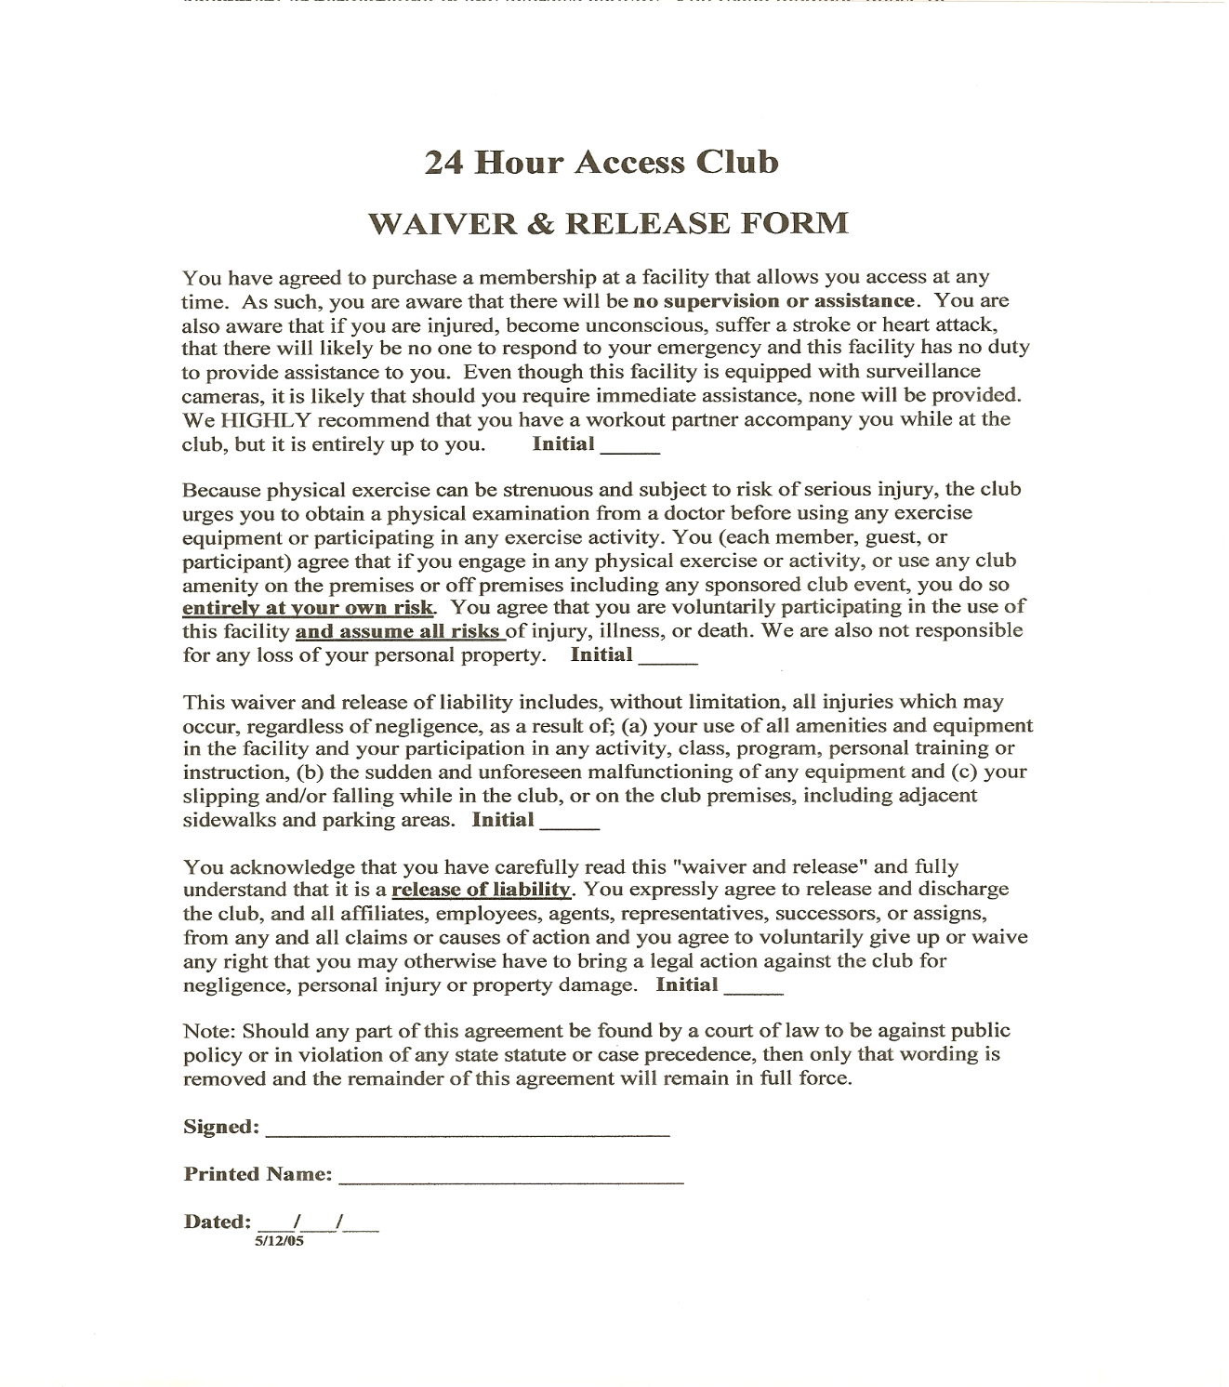

Member(s) Signature (Parent or Guardian if under 18 years of age):

#1 Signature: ________________________________ Print Name:____________________________ Date: _______

#2 Signature: ________________________________ Print Name:____________________________ Date: _______

#3 Signature: ________________________________ Print Name:____________________________ Date: _______

#4 Signature: ________________________________ Print Name:____________________________ Date: _______